***DR JACK TAN WEI CHIEH***

**MBBS, MRCP (UK)**

**M Med (Internal Medicine), ACSM**

**FAMS (Cardiology & ICM), FRCP, FACC, FESC, MBA**

### Dr Jack Tan graduated from the Faculty of Medicine, National University of Singapore in 1997. In 2007, he spent one year at UC Davis Medical Center, Sacramento with Dr John Laird to complete his peripheral vascular interventional program. He is doubly accredited for cardiology and intensive care medicine in Singapore. He is the head of cardiology at the National Heart Centre Singapore. He is a practising interventional cardiologist and holds associate professor appointments at Duke NUS and lecturer appointments at the Yong Loo Lin and Lee Kong Chian School of Medicine. In 2013, he was in the Dean’s list for his cohort at the Singapore Management University for his executive MBA.

### Dr Jack Tan successfully organized the ASEAN Federation of Cardiology Congress 2012 as the scientific chairman and was the organizing chairman for the APSC (Asian Pacific Society of Cardiology) meeting 2017 together with the WHF summit in Singapore. Currently he is an executive board member at Singapore Heart Foundation, APSIC ([Asian Pacific Society of Interventional Cardiology)](https://www.google.com.sg/url?sa=t&rct=j&q=&esrc=s&source=web&cd=5&cad=rja&uact=8&ved=0CDoQFjAE&url=http%3A%2F%2Fwww.apsic.net%2F&ei=TiJKVdOZLYuUuQS754HIDA&usg=AFQjCNHNm9LnrAo1ATI4lhWkSMcw0xFCHg&sig2=nE5Oxtp0iTr06wYJ7mLpXw&bvm=bv.92291466,d.c2E) and ISCP(International Society of Cardiovascular Pharmacotherapy) . He is the past president of SCS (Singapore Cardiac Society) and past board member (Continental chair) of WHF (World Heart Federation). He is the immediate past president of APSC and ISCP. In 2020, he was awarded the Public Administration Medal (Bronze) Pingat Pentadbiran AwamPPA(G) during Singapore’s National Day from the Prime Minister’s Office, followed by the Long Service Medal (Pingat Bakti Setia, PBS) in 2021.

**Mission Statement**

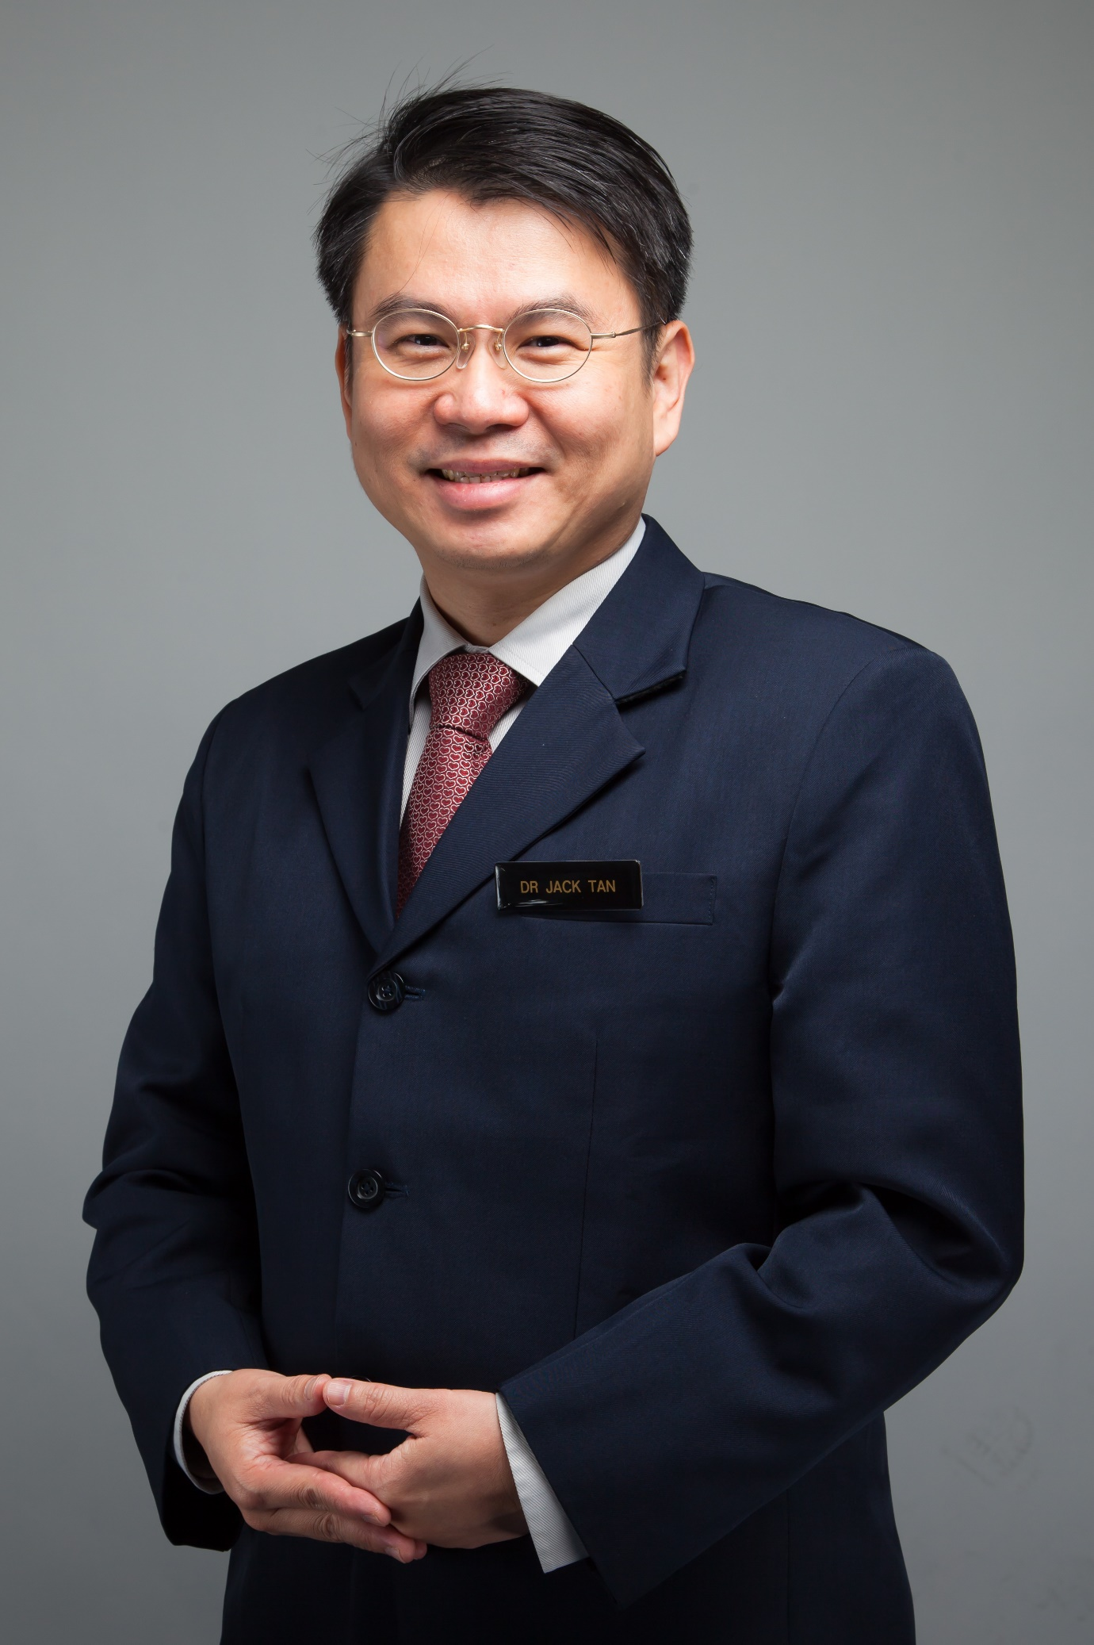

Dear Members of the WHF,

My name is Jack Tan from Singapore and I am a cardiologist. I am running for a role as WHF Member At Large.

My personal motivation has always been to help the community at large advance and advocate for better cardiovascular care. This need is striking in my part of the world in Asia and particularly south Asia where there is still a wide gap in addressing common risk factors like hypertension, diabetes, dyslipidaemia, tobacco use and obesity, the 5 big killers.

Having board experience in the Singapore Heart Foundation and Singapore Cardiac Society has also helped me realize the synergistic roles that professional cardiac societies and NGOs play in this space. My personal involvements in delivering educational and professional activities at the Asian Pacific society of cardiology and prior networks at WHF has helped me see how a convenor like WHF can push agendas that benefit regional societies and networks to help each other, which we sorely need more of.

I hope to be able to contribute as one of the members at large representing Asia and the WHF.